**[13] Design PDA Which Accepts String AABB**

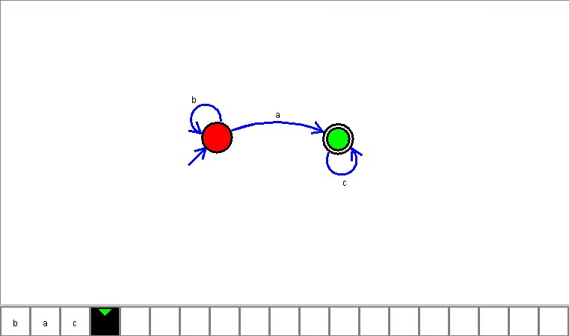

**Result**

The PDA is designed to compute the given strings as input using Simulator